**Report**

**For**

**Code Gladiators**

**Round 3**

**Leader: Dhruv Bhaveshkumar Dani**

**E-mail:** [**dhruvbdani@gmail.com**](mailto:dhruvbdani@gmail.com)

**Contact: 9320099436**

**Team Mate: Nilay Ketan Thakkar**

**E-mail:** [**nilay2620@gmail.com**](mailto:nilay2620@gmail.com)

**Contact: 9727945621**

**Question 1:**

The skeleton of a Aurochs has been found. Investigation shows the bones have lost 58% of the carbon-14 that was available when the Aurochs died. How old is the skeleton? The essential equation for radioactive decay is:

**Mt = k2 t/h**

where k is the original mass of the element, h is its half-life, and Mt is the mass of the element at time t. To calculate the age of the skeleton, we have to derive a value for t. Carbon-14 has a half-life of 5730 years. The present mass of C 14 is 0.58 less than the original mass, k. Therefore the present mass is k - 0.58k = 0.42k.

Sample Output:-

How much carbon has been lost (0-100%)?58

The object is 7171.317135 years old.

**Source Code:**

#include <stdio.h>

#include <math.h>

int main()

{

double half_life=5730.0, age, C_remain, C_lost;

clrscr();

printf("How much carbon has been lost (0-100%%)? ");

scanf("%lf", &C_lost);

C_remain = 1.0 - (C_lost/100.0);

age = -(half_life / log10(2.0)) * log10(C_remain);

printf("The object is %lf years old.\n", age);

getch();

return 0;

}

**Sample Output:**

How much carbon has been lost (0-100%)?58

The object is 7171.317135 years old.

**Question 2:**

Animate an emoji face according to the emotion taken as the user input which appears at random position on screen. The Program will run forever until the user enters Exit code. Each time a user enters an emotion an emoji for that emotion appears at a random position on screen.

**Source Code:**

#include<graphics.h>

#include<conio.h>

#include<stdlib.h>

#define interval 500

void smile()

{

int gd = DETECT, gm, area, temp1, temp2, left = 25, top = 75;

void *p;

clrscr();

initgraph(&gd, &gm, "C:\\TurboC3\\BGI");

setcolor(YELLOW);

circle(50, 100, 25);

setfillstyle(SOLID_FILL, YELLOW);

floodfill(50, 100, YELLOW);

setcolor(BLACK);

setfillstyle(SOLID_FILL, BLACK);

fillellipse(44, 92, 2, 6);

fillellipse(56, 92, 2, 6);

ellipse(50, 100, 205, 335, 20, 14);

ellipse(50, 100, 205, 335, 20, 15);

ellipse(50, 100, 205, 335, 20, 16);

area = imagesize(left, top, left + 50, top + 50);

p = malloc(area);

setcolor(WHITE);

settextstyle(SANS_SERIF_FONT, HORIZ_DIR, 3);

outtextxy(0, 451, "Smile Face Animation ");

settextstyle(SANS_SERIF_FONT, HORIZ_DIR, 1);

outtextxy(430,452,"(Press any key to exit)");

setcolor(BLUE);

rectangle(0, 0, 639, 449);

while(!kbhit())

{

temp1 = 1 + random (588);

temp2 = 1 + random (380);

getimage(left, top, left + 50, top + 50, p);

putimage(left, top, p, XOR_PUT);

putimage(temp1 , temp2, p, XOR_PUT);

delay(interval);

left = temp1;

top = temp2;

}

getch();

closegraph();

}

void surprise()

{

int gd = DETECT, gm, area, temp1, temp2, left = 25, top = 75;

void *p;

clrscr();

initgraph(&gd, &gm, "C:\\TurboC3\\BGI");

setcolor(YELLOW);

circle(50, 100, 25);

setfillstyle(SOLID_FILL, YELLOW);

floodfill(50, 100, YELLOW);

setcolor(BLACK);

setfillstyle(SOLID_FILL, BLACK);

fillellipse(44, 87, 2, 6);

fillellipse(56, 87, 2, 6);

fillellipse(50,110,12,8);

area = imagesize(left, top, left + 50, top + 50);

p = malloc(area);

setcolor(WHITE);

settextstyle(SANS_SERIF_FONT, HORIZ_DIR, 3);

outtextxy(0, 451, "Surprise Face Animation ");

settextstyle(SANS_SERIF_FONT, HORIZ_DIR, 1);

outtextxy(430,452,"(Press any key to exit)");

setcolor(BLUE);

rectangle(0, 0, 639, 449);

while(!kbhit())

{

temp1 = 1 + random (588);

temp2 = 1 + random (380);

getimage(left, top, left + 50, top + 50, p);

putimage(left, top, p, XOR_PUT);

putimage(temp1 , temp2, p, XOR_PUT);

delay(interval);

left = temp1;

top = temp2;

}

getch();

closegraph();

}

void sad()

{

int gd = DETECT, gm, area, temp1, temp2, left = 25, top = 75;

void *p;

clrscr();

initgraph(&gd, &gm, "C:\\TurboC3\\BGI");

setcolor(YELLOW);

circle(50, 100, 25);

setfillstyle(SOLID_FILL, YELLOW);

floodfill(50, 100, YELLOW);

setcolor(BLACK);

setfillstyle(SOLID_FILL, BLACK);

fillellipse(44, 87, 2, 6);

fillellipse(56, 87, 2, 6);

arc(50,120,35,145,15);

arc(50,120,35,145,14);

arc(50,120,35,145,15);

area = imagesize(left, top, left + 50, top + 50);

p = malloc(area);

setcolor(WHITE);

settextstyle(SANS_SERIF_FONT, HORIZ_DIR, 3);

outtextxy(0, 451, "Sad Face Animation ");

settextstyle(SANS_SERIF_FONT, HORIZ_DIR, 1);

outtextxy(430,452,"(Press any key to exit)");

setcolor(BLUE);

rectangle(0, 0, 639, 449);

while(!kbhit())

{

temp1 = 1 + random (588);

temp2 = 1 + random (380);

getimage(left, top, left + 50, top + 50, p);

putimage(left, top, p, XOR_PUT);

putimage(temp1 , temp2, p, XOR_PUT);

delay(interval);

left = temp1;

top = temp2;

}

getch();

closegraph();

}

void wink()

{

int gd = DETECT, gm, area, temp1, temp2, left = 25, top = 75;

void *p;

clrscr();

initgraph(&gd, &gm, "C:\\TurboC3\\BGI");

setcolor(YELLOW);

circle(50, 100, 25);

setfillstyle(SOLID_FILL, YELLOW);

floodfill(50, 100, YELLOW);

setcolor(BLACK);

setfillstyle(SOLID_FILL, BLACK);

fillellipse(43, 92, 2, 4);

fillellipse(57, 94, 4, 1);

setcolor(BLUE);

arc(43,100,80,115,15);

arc(57,105,60,105,15);

setcolor(BLACK);

ellipse(50, 100, 220, 335, 10, 9);

ellipse(50, 100, 220, 335, 10, 7);

ellipse(50, 100, 220, 335, 10, 8);

area = imagesize(left, top, left + 50, top + 50);

p = malloc(area);

setcolor(WHITE);

settextstyle(SANS_SERIF_FONT, HORIZ_DIR, 3);

outtextxy(0, 451, "Wink Face Animation ");

settextstyle(SANS_SERIF_FONT, HORIZ_DIR, 1);

outtextxy(430,452,"(Press any key to exit)");

setcolor(BLUE);

rectangle(0, 0, 639, 449);

while(!kbhit())

{

temp1 = 1 + random (588);

temp2 = 1 + random (380);

getimage(left, top, left + 50, top + 50, p);

putimage(left, top, p, XOR_PUT);

putimage(temp1 , temp2, p, XOR_PUT);

delay(interval);

left = temp1;

top = temp2;

}

getch();

closegraph();

}

void angry()

{

int gd = DETECT, gm, area, temp1, temp2, left = 25, top = 75;

void *p;

clrscr();

initgraph(&gd, &gm, "C:\\TurboC3\\BGI");

setcolor(RED);

circle(50, 100, 25);

setfillstyle(SOLID_FILL, RED);

floodfill(50, 100, RED);

setcolor(BLACK);

setfillstyle(SOLID_FILL, BLACK);

fillellipse(43, 97, 2, 6);

fillellipse(57, 97, 2, 6);

// setcolor(YELLOW);

// setfillstyle(LINE_FILL,BLACK);

// line(19,10,30,15);

// line(35,15,44,10);

setcolor(BLACK);

arc(50,122,40,140,15);

arc(50,122,40,140,14);

arc(50,122,40,140,15);

area = imagesize(left, top, left + 50, top + 50);

p = malloc(area);

setcolor(WHITE);

settextstyle(SANS_SERIF_FONT, HORIZ_DIR, 3);

outtextxy(0, 451, "Angry Face Animation ");

settextstyle(SANS_SERIF_FONT, HORIZ_DIR, 1);

outtextxy(430,452,"(Press any key to exit)");

setcolor(WHITE);

rectangle(0, 0, 639, 449);

while(!kbhit())

{

temp1 = 1 + random (588);

temp2 = 1 + random (380);

getimage(left, top, left + 50, top + 50, p);

putimage(left, top, p, XOR_PUT);

putimage(temp1 , temp2, p, XOR_PUT);

delay(interval);

left = temp1;

top = temp2;

}

getch();

closegraph();

}

int main()

{

int choice,flag=0;

clrscr();

while(flag==0)

{

printf("\nMENU");

printf("\n------------------------\n");

printf("1.Smile\n");

printf("2.Surprise\n");

printf("3.Sad\n");

printf("4.Wink\n");

printf("5.Angry\n");

printf("\nPress 0 To Exit.\n");

printf("\nEnter Choice:=> ");

scanf("%d",&choice);

switch(choice)

{

case 0:

flag=1;

break;

case 1:

smile();

break;

case 2:

surprise();

break;

case 3:

sad();

break;

case 4:

wink();

break;

case 5:

angry();

break;

default:

clrscr();

printf("[:Invalid Input:]\nPlease Try Again . . .\n");

}

}

printf("\n------------------------\nPress any key to exit.");

getch();

return 0;

}

**Sample Output:**

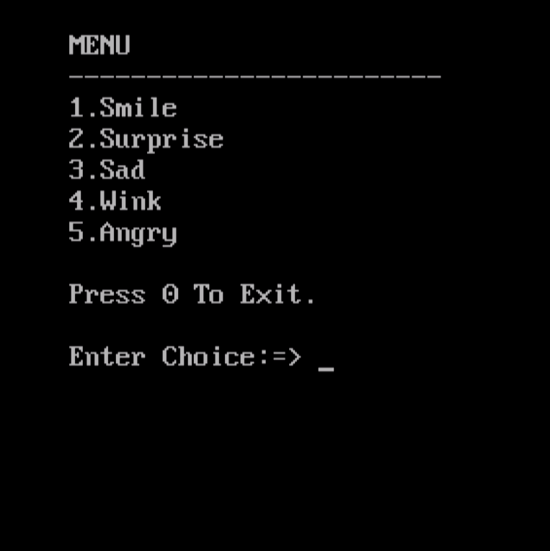

**Invalid Input:**

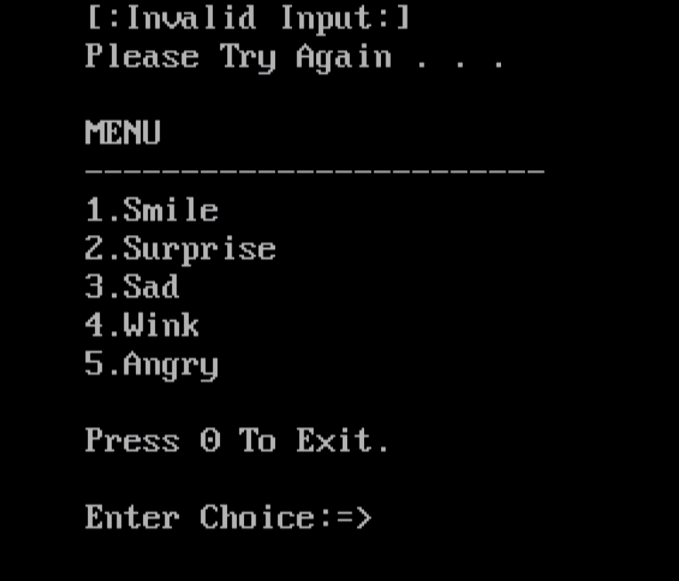

**Smile Emoji:**

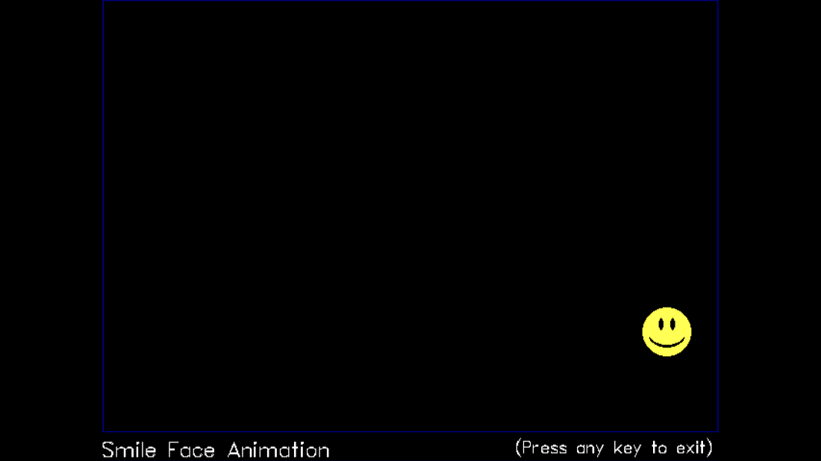

**Surprise Emoji:**

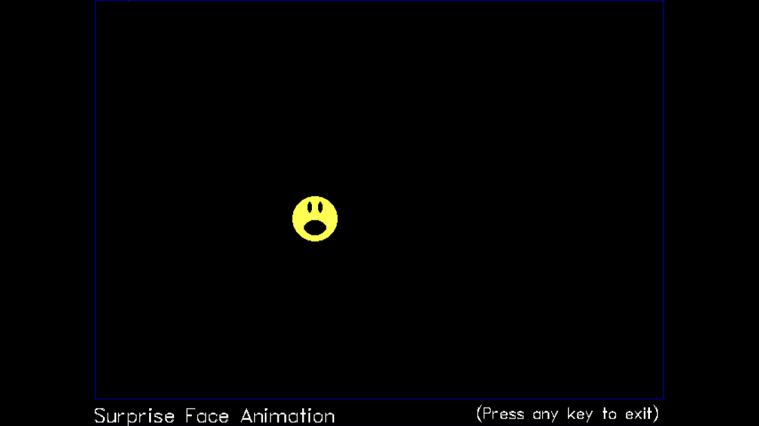

**Sad Emoji:**

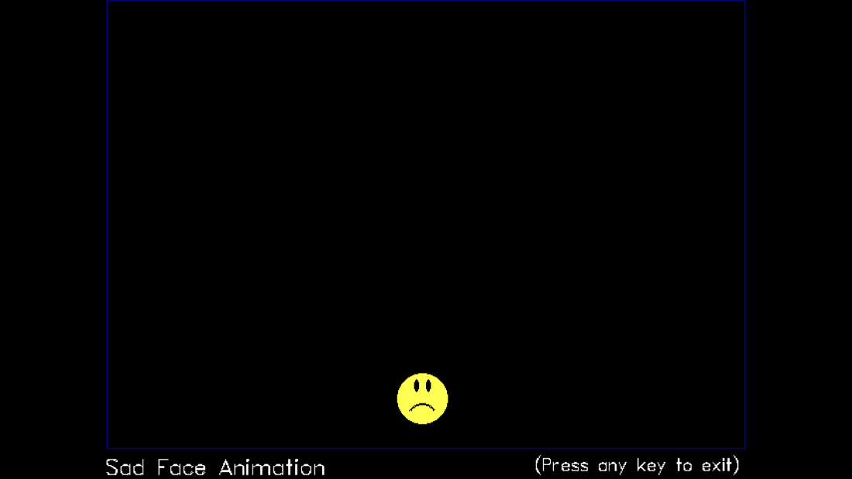

**Wink Emoji:**

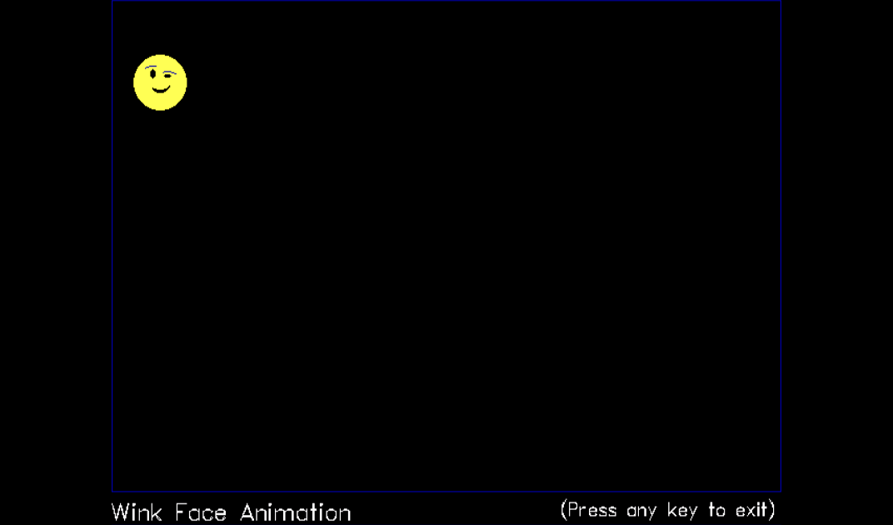

**Angry Emoji:**

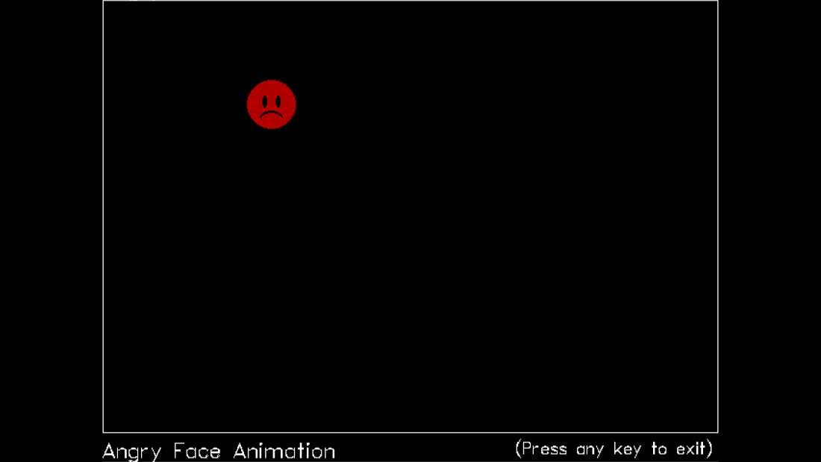

**THANK YOU**